ECAO3O5- SIGNALS AND SYSTEMS
NAME: S.GOKUL
REG NO: 192512373
Experiment No.: 6
Title: Parseval's Relation and Harmonic Spectrum Analysis
Objective (i): To verify Parseval’s relation for continuous-time periodic signals and analyze the relationship between time-domain and frequency-domain power.
AIM
To verify Parseval's relation for a continuous-time periodic signal and analyze the relationship between its time-domain and frequency-domain power using MATLAB.
APPARATUS / SOFTWARE REQUIRED
1. Computer / Laboratory PC
2. MATLAB software (with Signal Processing environment)
THEORY
Parseval's relation states that the average power of a periodic signal calculated in the time domain over one period is equal to the sum of the powers of its Fourier-series components in the frequency domain. Power can therefore be computed either from the waveform or from the Fourier coefficients.
For the half-wave rectified sinusoid x(t) = max[sin(2πt), 0] with T₀ = 1 s, the time-domain power is P = ∫₀^0.5 sin²(2πt) dt = 0.25. In the frequency domain, the DC power is a₀²/4 and each harmonic contributes ½(aₙ² + bₙ²). Using 20 harmonics, both values agree very closely.
FORMULAE USED
P = (1/T₀) ∫ |x(t)|² dt (over one period)
Parseval's relation: P = a₀²/4 + ½ Σ (aₙ² + bₙ²)
Absolute error = |P_time − P_freq|
ALGORITHM / PROCEDURE
- Start MATLAB and generate the half-wave rectified sinusoid over one period (T₀ = 1 s).
- Compute the time-domain average power using numerical integration (trapz).
- Calculate the Fourier coefficients a₀, aₙ and bₙ up to N = 20.
- Evaluate the frequency-domain power using Parseval's relation.
- Compare the two power values and calculate the absolute error.
- Plot the two power values as a bar chart.
INPUT PARAMETERS
S.No. | Input Parameter | Symbol / Setting | Value | Unit
1 | Fundamental frequency | f₀ | 1 | Hz
2 | Period | T₀ | 1 | s
3 | Number of harmonics | N | 20 | —
4 | Signal | x(t) | Half-wave rectified sinusoid | —

PROGRAM (MATLAB CODE)
clc; clear; close all;
%% 6(i) Verification of Parseval's Relation for Periodic Signals
figure;
% Verification of Parseval's Relation
f0 = 1;
T = 1/f0;
t = linspace(0,T,4000);
x = max(sin(2*pi*f0*t),0);
% Time-domain average power
P_time = (1/T)*trapz(t,abs(x).^2);
% Fourier-series coefficients
N = 20;
a0 = (2/T)*trapz(t,x);
an = zeros(1,N); bn = zeros(1,N);
for k = 1:N
an(k) = (2/T)*trapz(t,x.*cos(2*pi*k*f0*t));
bn(k) = (2/T)*trapz(t,x.*sin(2*pi*k*f0*t));
end
% Frequency-domain power using Parseval's relation
P_freq = a0^2/4 + 0.5*sum(an.^2 + bn.^2);
fprintf('Time-domain power = %.6f\n',P_time);
fprintf('Frequency-domain power = %.6f\n',P_freq);
fprintf('Absolute error = %.6e\n',abs(P_time-P_freq));
bar([P_time P_freq]);
set(gca,'XTickLabel',{'Time Domain','Frequency Domain'});
ylabel('Average Power'); grid on;
title('Verification of Parseval''s Relation');
OUTPUT
Command Window:
Time-domain power = 0.250000
Frequency-domain power = 0.249996
Absolute error = 3.640800e-06

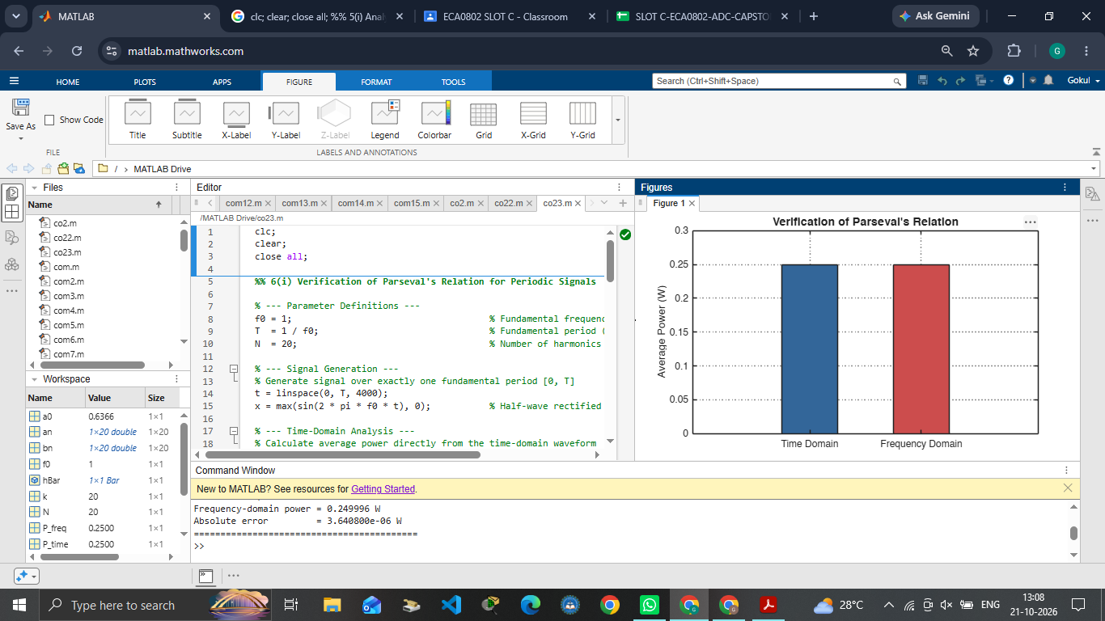
Fig. 6.1 Time-domain and frequency-domain average power (Parseval's relation)
OUTPUT PARAMETERS (THEORETICAL vs SIMULATED)
S.No. | Output Parameter | Theoretical Value | Simulated Value | % Deviation
1 | Time-domain power | 0.25 | 0.250000 | 0 %
2 | Frequency-domain power | 0.25 | 0.249996 | ≈ 0.002 %
3 | Absolute error | ≈ 0 | 3.64 × 10⁻⁶ | Small
4 | Signal period | 1 s | 1 s | 0 %

RESULT
Parseval's relation was verified for the half-wave rectified sinusoid. The time-domain power is 0.250000 and the frequency-domain power (DC term plus 20 harmonics) is 0.249996, with an absolute error of only 3.64 × 10⁻⁶, so the two values agree.

Experiment No.: 6
Title: Parseval's Relation and Harmonic Spectrum Analysis
Objective (iv): To compare the total power obtained in the time domain with the harmonic power distribution in the frequency domain.
AIM
To compare the total power obtained in the time domain with the harmonic power distribution (DC and harmonic components) in the frequency domain using MATLAB.
APPARATUS / SOFTWARE REQUIRED
1. Computer / Laboratory PC
2. MATLAB software (with Signal Processing environment)
THEORY
The total average power of a periodic signal can be obtained from the waveform in the time domain, or as the sum of the DC power and the powers of all harmonic components in the frequency domain. By Parseval’s relation, both results must be equal.
For the half-wave rectified sinusoid, the DC power is a₀²/4 = 1/π² ≈ 0.1013 and the harmonic components contribute the remaining power, so the total is 0.25. The sum of the DC power and the harmonic powers calculated from the Fourier coefficients (N = 20) is compared with the time-domain power.
FORMULAE USED
P_frequency = P_DC + P_harmonics
P_DC = a₀²/4
P_harmonics = ½ Σ (aₙ² + bₙ²)
P_time = (1/T₀) ∫ x²(t) dt (over one period)
ALGORITHM / PROCEDURE
- Start MATLAB and generate the half-wave rectified sinusoid over one period.
- Compute the time-domain average power using numerical integration.
- Calculate the Fourier coefficients a₀, aₙ and bₙ for n = 1 to 20.
- Calculate the DC power and the total harmonic power from the coefficients.
- Add the DC power and harmonic power to obtain the frequency-domain power.
- Display the power values and compare the time-domain and frequency-domain power using a bar chart.
INPUT PARAMETERS
S.No. | Input Parameter | Symbol / Setting | Value | Unit
1 | Fundamental frequency | f₀ | 1 | Hz
2 | Period | T₀ | 1 | s
3 | Number of harmonics | N | 20 | —
4 | Signal | x(t) | Half-wave rectified sinusoid | —

PROGRAM (MATLAB CODE)
clc; clear; close all;
%% 6(iv) Comparison of Time-Domain Power with Frequency-Domain Harmonic Power
figure;
% Time-Domain and Frequency-Domain Power Comparison
f0 = 1; T = 1/f0;
t = linspace(0,T,4000);
x = max(sin(2*pi*f0*t),0);
P_time = (1/T)*trapz(t,x.^2);
N = 20;
a0 = (2/T)*trapz(t,x);
an = zeros(1,N); bn = zeros(1,N);
for k = 1:N
an(k) = (2/T)*trapz(t,x.*cos(2*pi*k*f0*t));
bn(k) = (2/T)*trapz(t,x.*sin(2*pi*k*f0*t));
end
P_dc = a0^2/4;
P_harmonics = 0.5*sum(an.^2+bn.^2);
P_frequency = P_dc + P_harmonics;
fprintf('Time-domain power = %.6f\n',P_time);
fprintf('DC power = %.6f\n',P_dc);
fprintf('Harmonic power = %.6f\n',P_harmonics);
fprintf('Frequency-domain power = %.6f\n',P_frequency);
bar([P_time P_frequency]);
set(gca,'XTickLabel',{'Time Domain','Frequency Domain'});
ylabel('Average Power'); grid on;
title('Time-Domain vs Frequency-Domain Power');
OUTPUT
Command Window:
Time-domain power = 0.250000
DC power = 0.101321
Harmonic power = 0.148675
Frequency-domain power = 0.249996

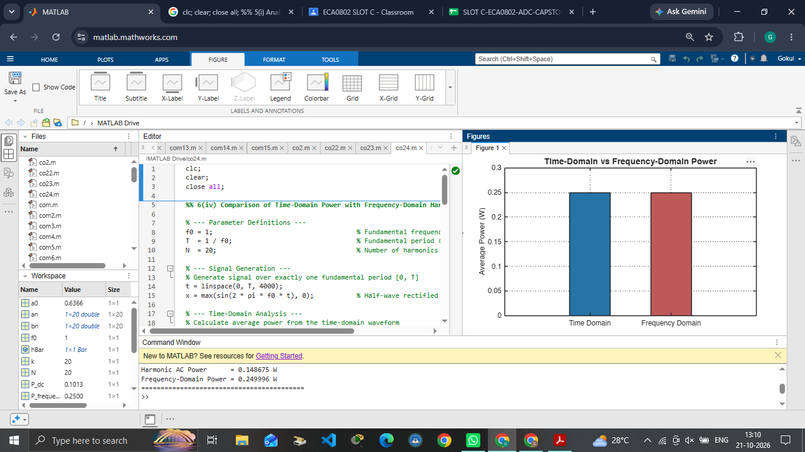
Fig. 6.2 Time-domain power compared with frequency-domain power (DC + harmonics)
OUTPUT PARAMETERS (THEORETICAL vs SIMULATED)
S.No. | Output Parameter | Theoretical Value | Simulated Value | % Deviation
1 | Time-domain power | 0.25 | 0.250000 | 0 %
2 | DC power a₀²/4 | 1/π² = 0.1013 | 0.101321 | ≈ 0 %
3 | Harmonic power ½Σ(aₙ²+bₙ²) | 0.25 − 0.1013 = 0.1487 | 0.148675 | ≈ 0 %
4 | Frequency-domain power | 0.25 | 0.249996 | ≈ 0.002 %

RESULT
The total time-domain power of the half-wave rectified sinusoid is 0.250000. The frequency-domain power is the sum of the DC power (0.101321) and the harmonic power (0.148675), which equals 0.249996. The two values agree, confirming that the total power equals the sum of the DC and harmonic powers.

LABORATORY PERFORMANCE ASSESSMENT RUBRICS:

Objective | Assessment Criterion | Excellent – 4 | Good – 3 | Satisfactory – 2 | Needs Improvement – 1 | Weightage | Marks(10) | Marks obtained
(i) To verify Parseval's relation for continuous-time periodic signals and analyze the relationship between time-domain and frequency-domain power. | Fourier Series Coefficient Computation | Correctly identifies the fundamental period T0 and frequency ω0 of the periodic signal. Computes the Fourier series coefficients (c_k, or a_k and b_k) accurately, analytically or in MATLAB, and plots the signal with its harmonic reconstruction with correct labels and scaling. | Computes the coefficients correctly with minor errors in the period, limits, scaling or labelling. | Computes only some coefficients correctly, or has noticeable errors in T0, integration or code, and needs guidance. | Unable to determine the period or compute the Fourier series coefficients. | 20 | 2
 | Time-Domain Power & Parseval Verification | Correctly computes the average power P .Applies Parseval's relation correctly, verifies that the two values agree within a small numerical error, and explains the time-frequency relationship clearly. | Computes the power and applies Parseval's relation correctly, with minor numerical or interpretation errors. | Computes the time-domain power or applies Parseval's relation only partly. Verification is incomplete or has noticeable errors, and needs guidance. | Unable to compute the power or verify Parseval's relation. | 20 | 2
(ii) To compare the total power obtained in the time domain with the harmonic power distribution in the frequency domain. | Harmonic Power Distribution | Correctly computes the power in each harmonic and the DC power. Plots the power spectrum (stem plot) with labelled axes, shows the cumulative power, and identifies the dominant harmonics accurately. | Computes the harmonic powers and plots the spectrum correctly, with minor errors in indexing, scaling or labelling. | Computes some harmonic powers but has noticeable errors in the spectrum or the DC and harmonic terms, and needs assistance. | Unable to compute or plot the harmonic power distribution. | 20 | 2
 | Time vs Frequency Power Comparison | Compares total time-domain power with the sum of harmonic powers for an increasing number of harmonics. Reports the percentage error and the power captured, explains convergence and the effect of truncation (for example for square or triangular waves), and draws correct conclusions. | Compares the total powers correctly, with minor errors in the error calculation or limited explanation of convergence. | Makes a basic comparison with incomplete error analysis, or gives limited explanation, and needs guidance. | Unable to compare the time-domain and frequency-domain power correctly. | 20 | 2
Interpret the results for both objectives and maintain a proper technical record. | Engineering Analysis, Record & Interpretation | Provides technically accurate interpretation of the results, relating power to harmonic content and signal waveform. Maintains a complete record with aim, theory, MATLAB code, plots, observations, result and conclusion, with clear organization. | Maintains a proper record and gives mostly accurate interpretation, with minor omissions in explanation or presentation. | Record and interpretation are basic, with partial explanation or missing elements. | Incomplete record, limited or incorrect interpretation of the results. | 20 | 2
 |  |  |  |  | Total | 100 | 10

